Group 8: Tritha, Jannavi, Debartha
Capstone 1:Domain 2
Customer Churn Prediction and Retention Framework for ConnectTel Communications

1. Business Problem
ConnectTel Communications operates as one of the largest telecommunications service providers in its region and has invested heavily to expand its network, launch customer acquisition campaigns, and in digital transformation to strengthen its competitive market position. While ConnectTel is able to attract new subscribers, there is a rising trend in customer attrition across multiple core service categories.
Several operational departments have highlighted underlying drivers of this customer attrition and the business risks associated with them.
Some of the potential business problems currently identified are:
- Varying network quality across regions
- Rise in service quality issues and slow resolution time
- Ineffective retention campaigns

2.0 Business Objective
Senior management wants to move away from reactive interventions and transition toward a proactive customer retention model. The primary objective of this framework is to identify high-risk customers early, enabling targeted intervention strategies before actual churn occurs to protect long-term revenue growth, enhance customer experience, and improve retention rates.
The second objective is to identify the key factors that can help predict customer churn and assess the impact of above mentioned factors raised by the various teams on customer churn.
The existing dataset has been compiled from multiple systems and contains numerous legacy attributes from discontinued platforms. As data storage incurs cost, the third objective is to streamline the dataset by eliminating redundant and irrelevant information.

2.1 Analytical Objective
The aim is to find the best predictive model for the given dataset that could identify at-risk customers with highest accuracy and precision and uncover key factors associated with churn prediction. Different models need to be developed and evaluated using statistical metrics to compare their performance.

3. Challenges and Constraints
- Class Imbalance in Customer Attrition: Severe class imbalance—where active customers significantly outnumber churned ones—induces model bias. This can cause a high rate of false-negative where the model can fail to identify at-risk customers.
- Legacy Systems and Data Integration: The dataset is compiled from multiple systems. Standardizing, cleaning, and operationalizing these disjointed schemas introduces significant technical challenges regarding data type, duplicate fields, missing values, and data integrity.
- Model Retraining Pipelines: Over time, the model will experience concept drift where model parameters trained on historical data don’t hold anymore due to changing business and demographic landscape . It will require retraining the model on the latest dataset.
- Operational Adoption: Moving from a reactive model to a proactive model requires significant operational shifts. Business alignment must be built across different teams to trust the model and act upon the predicted at risk customers before the customer actively starts looking out.
4. Literature Review of Selected Research Papers

Paper | Model | Performance | Key Strength | Project Fit
Explainable AI with SHAP (El Attar &n Mohammed, 2025) | XGBoost + SHAP | AUC: 0.932 | High predictive performance with explainable feature importance using SHAP values | Supports proactive customer intervention by identifying key churn drivers
CRM-Integrated Random Forest (Khoh & Pang, 2025) | Random Forest + CRM | Accuracy: 95.13%, AUC: 0.89 | Strong predictive capability with integration into CRM workflows and KPI tracking | Enables operational decision-making and targeted retention actions
FCLCNN-LSTM Spatio-Temporal Model (Zhang et al., 2024) | FCLCNN-LSTM | Accuracy: 92.2% | Captures complex spatial-temporal patterns across multiple data sources | Suitable for analyzing multi-source telecom data and evolving customer behavior

5. Proposed Methodology

- Data Understanding: Explore the raw data to understand its structure, distributions, and anomalies using charts, box plot and two-way tables.
- Data Preprocessing & Cleaning: Handle missing data fields, remove duplicate records, and remove noisy data.
- Exploratory Data Analysis: Analyze the dataset to look for patterns, trends, outliers, possible association between variables and customer churn. Address class imbalance using oversampling methodologies (e.g., SMOTE)
- Feature Engineering & Selection. Apply categorical encoding, feature scaling and transformation as required. Use correlation matrices and statistical models (e.g. PCA) to identify important predictive variables.
- Predictive Model Development: Train a baseline classification pipeline using Logistic Regression, followed by advanced ensemble methods including Random Forests and XGBoost.
- Evaluation and Model Selection: Validate model performance against an optimization matrix consisting of Precision, Recall, F1-Score, and ROC-AUC.

6. Workflow & Timelines

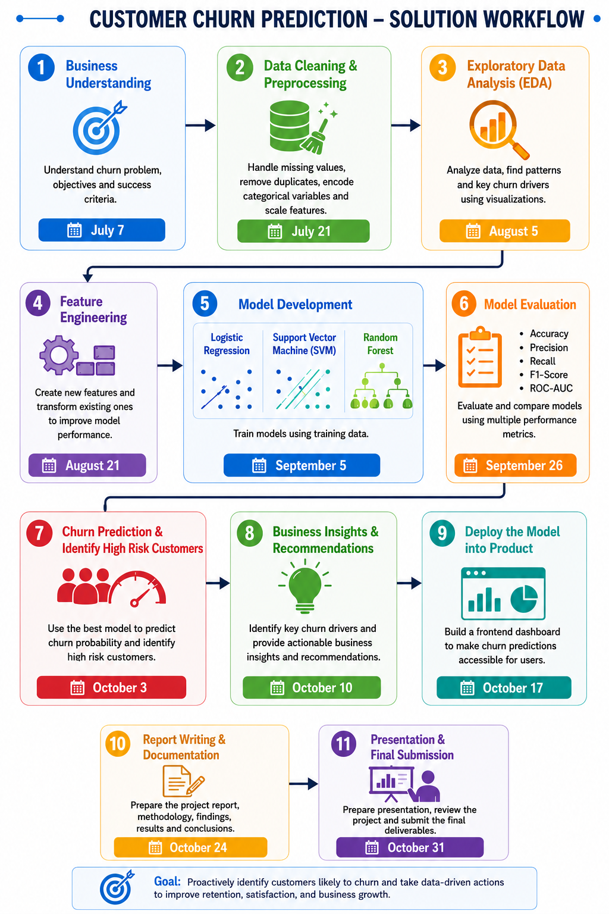

7. Deliverables
- Data Analysis Report
- Model Evaluation and Selection
- Business Recommendations
- Deployment and front end Dashboard
- Final Presentation
- Technical Documentation

